9. ReactJS-HOL

Create a React Application named “cricketapp” with the following components:

1. List of Players

· Declare an array with 11 players and store details of their names and scores using the map feature of ES6

code:

PS C:\Users\lenovo> node -v V22.17.0

PS C:\Users\lenovo> npm -v 10.9.2

PS C:\Users\lenovo> npx create-react-app cricketapp PS C:\Users\lenovo\cricketapp> npm start

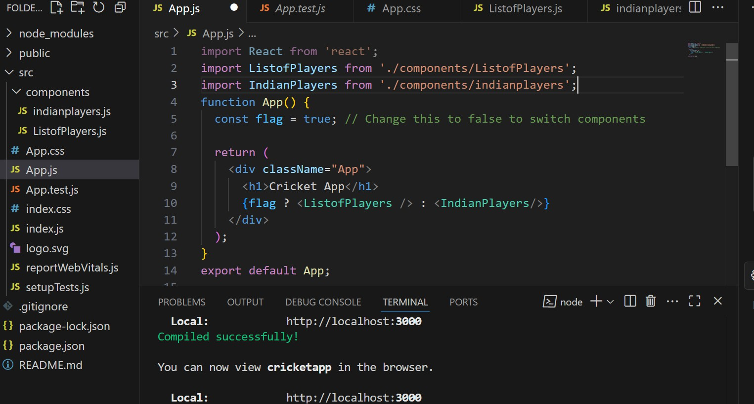

IndianPlayers.js

import React from 'react';

const IndianPlayers = () => {

const allPlayers = ['Sachin1', 'Dhoni2', 'Virat3', 'Rohit4', 'Yuvaraj5', 'Raina6'];

// Using destructuring + filter for odd/even positions

const oddPlayers = allPlayers.filter((_, index) => index % 2 === 0); const evenPlayers = allPlayers.filter((_, index) => index % 2 !== 0);

const T20Players = ['Mr. First Player', 'Mr. Second Player', 'Mr. Third Player'];

const RanjiTrophyPlayers = ['Mr. Fourth Player', 'Mr. Fifth Player', 'Mr. Sixth Player'];

const mergedPlayers = [...T20Players, ...RanjiTrophyPlayers];

return (

<div>

<h2>Odd Players</h2>

<ul>

{oddPlayers.map((player, index) => (

<li key={index}>

{index === 0 ? 'First' : index === 1 ? 'Third' : 'Fifth'} : {player}

</li>

))}

</ul>

<h2>Even Players</h2>

<ul>

{evenPlayers.map((player, index) => (

<li key={index}>

{index === 0 ? 'Second' : index === 1 ? 'Fourth' : 'Sixth'} :

{player}

</li>

))}

</ul>

<h2>List of Indian Players Merged:</h2>

<ul>

{mergedPlayers.map((player, index) => (

<li key={index}>{player}</li>

))}

</ul>

</div>

);

};

export default IndianPlayers;

Listofplayers.js

import React from 'react';

const ListofPlayers = () => { const players = [

{ name: 'Virat', score: 85 },

{ name: 'Rohit', score: 40 },

{ name: 'Dhoni', score: 95 },

{ name: 'KL Rahul', score: 62 },

{ name: 'Hardik', score: 45 },

{ name: 'Jadeja', score: 77 },

{ name: 'Bumrah', score: 33 },

{ name: 'Shami', score: 90 },

{ name: 'Pant', score: 54 },

{ name: 'Gill', score: 102 },

{ name: 'Surya', score: 66 }

];

const below70 = players.filter(player => player.score < 70);

return (

<div>

<h2>All Players</h2>

<ul>

{players.map((p, index) => (

<li key={index}>{p.name} - {p.score}</li>

))}

</ul>

<h3>Players with score below 70</h3>

<ul>

{below70.map((p, index) => (

<li key={index}>{p.name} - {p.score}</li>

))}

</ul>

</div>

);

};

export default ListofPlayers;

OUTPUT:

When flag=true

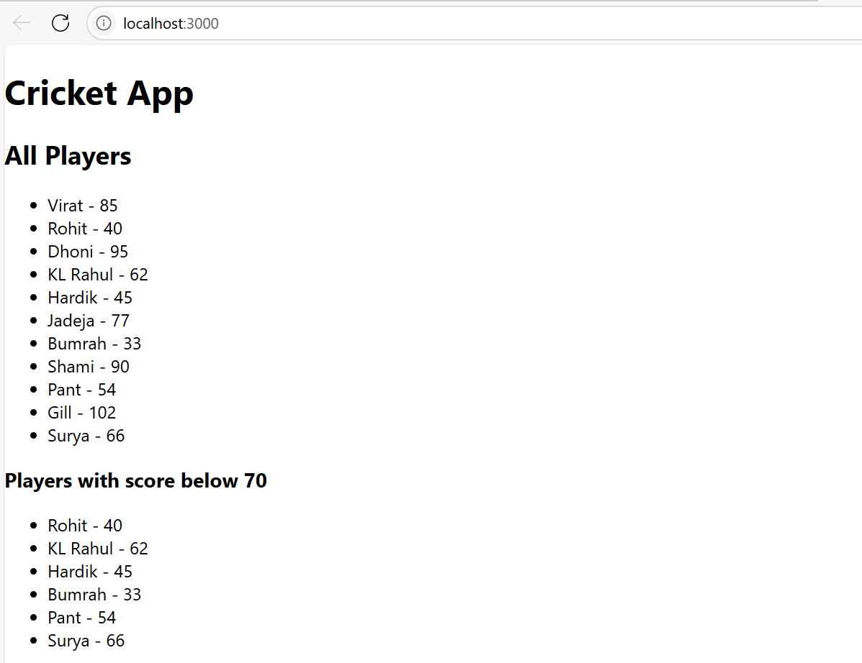

when flag=False

